DRIVING BUSINESS GROWTH THROUGH DATA: A SALES ANALYTICS APPROACH

On the Job Training Report submitted to Savitribai Phule Pune University,
Pune in partial fulfillment of requirement for the award of the degree of

MASTER OF BUSINESS ADMINISTRATION

By

Anurag Narendra Narkhede
Under the guidance of
Dr. Bhushan Pardeshi

PCET’S S.B.PATIL INATITUTE OF MANAGEMENT AND RESEARCH
Sector 26, Pradhikaran, Nigadi, Pimpri-chinchwad, Pune
2024-25

DECLARATION
I, Anurag Narendra Narkhede, a student of Master of Business Administration (MBA) (Batch 2024–2026) at PCET’s S. B. Patil Institute of Management and Research, hereby declare that the On Job Training (OJT) report titled:
“Driving Business Growth through Data: A Sales Analytics Approach at Kumar Coaters”
is the result of my original work carried out during my training period from 10th May to 10th August at Kumar Coaters.
This report has been prepared solely for academic purposes and has not been submitted earlier to any other university or institution for the award of any degree, diploma, or certificate.
The information provided in this report is accurate to the best of my knowledge and belief.

Signature Of Student

AKNOWLEDGEMENT
I take this opportunity to express my sincere gratitude to Kumar Coaters for providing me with the valuable opportunity to carry out my On Job Training (OJT) at their esteemed organization. It was a great learning experience to work in the real-world environment and apply my academic knowledge to practical challenges in the field of business analytics.
I am deeply thankful to my industry mentor and all the staff members at Kumar Coaters for their constant support, guidance, and encouragement throughout the training period. Their insights into sales operations and data handling played a vital role in shaping this project.
I extend my heartfelt thanks to Dr. Heena Mulaani, my faculty guide at PCET’s S. B. Patil Institute of Management and Research, for her continuous mentorship, constructive feedback, and motivation that helped me complete this project successfully.
I am also grateful to the Director and Faculty Members of the institute for creating a strong academic foundation and encouraging research-driven learning.
Finally, I thank my family and friends for their constant encouragement, moral support, and motivation throughout my MBA journey and during this project.

List of Tables :
Table no | Title | Page no
1 | Monthly Sales data of year 2023 | 22
2 | Monthly Sales data of year 2024 | 24
3 | Monthly Sales data of year 2025 | 26
4 | Service wise Sales data of year 2023 | 28
5 | Service wise Sales data of year 2024 | 29
6 | Service wise Sales data of year 2025 | 30
7 | Effect after implementation of ChatBot | 34
8 | Effect after implementation of AI sorting Model | 41

List of Charts:
Chart no | Chart Name | Page no
1 | Monthly Sales data of year 2023 | 22
2 | Monthly Sales data of year 2024 | 24
3 | Monthly Sales data of year 2025 | 26
4 | Service wise Sales data of year 2023 | 28
5 | Service wise Sales data of year 2024 | 29
6 | Service wise Sales data of year 2025 | 30
7 | Pattern Observed in Year 2023 | 23
8 | Pattern Observed in Year 2024 | 25
9 | Pattern Observed in Year 2025 | 26
10 | Pattern Observed in three Years | 27
11 | Seasonal Sales pattern in last two years | 31
12 | Pattern Observed after implementation of ChatBot | 34
13 | Pattern Observed after implementation of AI sorting Model | 41

Index
Sr. no | Title | Page no
1 | Executive Summary | 7
2 | Outline of the Problem | 8-9
3 | Objectives of the Study | 10
4 | Chapter I : Introduction to Theoretical Background | 11-14
5 | Chapter II : Review of Literature | 15-16
6 | Chapter III : Profile of the organization | 17-18
7 | Chapter IV : Research Methodology | 19-21
8 | Chapter V : Analysis and Interpretation of Data | 22-41
9 | Chapter VI : Findings, Conclusion and Suggestions | 42-43
10 | Annexure | 44-47
11 | References | 48

EXECUTIVE SUMMARY
In the era of digital transformation and rapid technological advancement, organizations are leveraging data to fuel decision-making and enhance business performance. With the growing importance of data analytics in every sector, the need to integrate data-driven strategies in traditional industries such as manufacturing and automotive services has become more critical than ever. This On Job Training (OJT) project titled "Driving Business Growth through Data: A Sales Analytics Approach" was conducted at Kumar Coaters, a surface treatment service provider specializing in ED Coating and Powder Coating for automotive components.
The primary objective of this project was to study historical sales data to understand service trends, identify high-performing and low-performing months, forecast future demand, and recommend business strategies to enhance overall sales performance. The project covered a span of two financial years: 2023–2024 and 2024–2025 (up to the current available months), with a focus on monthly sales figures across the company’s primary services.
Key insights were derived through the use of descriptive analytics (to understand past patterns and trends) and predictive analytics (to estimate future demand). Services were segmented, and seasonal trends were observed to identify peak and off-season months. Special attention was given to analyzing the reasons for fluctuating demand—be it client-specific cycles, market behavior, or industry seasonality.
Furthermore, the report provides practical suggestions to tackle off-season challenges through strategies like promotional pricing, process optimization, client outreach, and new market development. Likewise, during high-demand months, the recommendations include capacity expansion, resource pre-planning, and stock optimization to meet the service delivery targets without delays or quality compromises.
This report serves as a roadmap for Kumar Coaters to adopt data-driven decision-making across its operations. By integrating analytics into core business functions, the organization can strengthen its market position, improve client satisfaction, and ensure sustained growth in the highly competitive manufacturing service sector.

Outline of the Problem
Kumar Coaters is a reputed industrial service provider located in Maharashtra, India, specializing in surface coating solutions for automotive and engineering components. Established with the objective of delivering high-quality and durable coating services, the company has steadily built a strong reputation in the market for its consistency, precision, and client-centric approach.
The organization primarily offers two essential services:
- ED Coating (Electro Deposition Coating)
- Powder Coating
These coatings play a vital role in enhancing the durability, corrosion resistance, and visual appeal of metal parts used in the automotive, manufacturing, and engineering sectors. The services provided by Kumar Coaters are particularly critical for automotive suppliers, as they ensure that components such as engine covers, brake components, chassis parts, and fuel caps are protected against rust and environmental wear.
Kumar Coaters serves a wide range of clients, including Tier-1 and Tier-2 automotive suppliers. The company operates on a business-to-business (B2B) model and caters to both mass production and customized coating requirements. Its flexibility, quality assurance, and timely service have helped it maintain long-standing relationships with its clients.
The company operates from a strategically located industrial facility that is equipped with semi-automatic and manual coating lines, ovens, curing systems, and material handling units. This infrastructure allows Kumar Coaters to manage varying production loads while maintaining strict quality control standards. The organization follows well-defined standard operating procedures (SOPs) and adheres to industry safety norms.
In terms of organizational structure, Kumar Coaters follows a functional management approach. Departments such as Production, Quality Control, Sales, Procurement, and Maintenance operate under the supervision of department heads, who report to the General Manager. The Sales and Business Analytics functions play a critical role in client management, demand forecasting, and reporting—providing the base for strategic decision-making.
The company’s mission is to provide durable, high-quality, and cost-effective coating services while ensuring maximum client satisfaction through continuous improvement and innovation. Its vision is to be recognized as a leading coating service provider in the Indian automotive sector through technological adoption, sustainable practices, and a customer-first approach.
In recent years, Kumar Coaters has recognized the importance of leveraging data for operational and strategic advantages. It has begun to digitize sales records and analyze service trends, laying the foundation for integrating data analytics into regular business decision-making processes.
This organizational profile reflects the company's commitment to quality, customer satisfaction, and business excellence—making it a suitable environment for a data-driven project aimed at enhancing sales performance and business growth.

Objectives of the Study
1] To analyze and identify the company’s top-performing services through data-driven sales performance evaluation.
2] To detect seasonal sales patterns and provide strategic recommendations for navigating both off-season and peak-demand periods.
3] To bridge the gap between sales data insights and client engagement by proposing a smart chatbot solution for real-time communication.
4] To develop an AI model for automatic part identification and section-wise sorting (A–G) to streamline workshop operations.

Chapter I : Introduction and Theoretical Background
1. Introduction
In an increasingly competitive and data-driven business world, the ability to analyze, interpret, and apply data has become a vital element for organizational success. Traditional industries are no longer relying solely on experience and intuition for decision-making. Instead, they are embracing data analytics as a strategic asset to enhance operational efficiency, predict future trends, and develop competitive advantages.
This On Job Training (OJT) project titled “Driving Business Growth through Data: A Sales Analytics Approach” focuses on how Kumar Coaters, a service-based organization operating in the industrial coating sector, can utilize sales data to uncover hidden insights and strengthen its business performance.
The project was carried out over a period of three months (10 May to 10 August) with the objective of analyzing the company's sales performance data for ED coating and Powder coating services over two financial years (2023–2024 and 2024–2025). Through this analysis, the project aimed to identify:
- Trends in monthly demand
- Peak and off-season service periods
- Top-performing services
- Low-performing months
- Actionable recommendations for better planning
The focus was to bridge the gap between raw sales numbers and strategic decision-making, enabling the company to plan for seasonal variations, resource allocation, and customer targeting more effectively.
2. The Need for Sales Analytics in Service-Based Industries
While product-based industries have long relied on data for inventory, production, and sales planning, service-based industries like industrial coating have only recently begun to understand the transformative potential of data analytics.
Companies such as Kumar Coaters face unique challenges:
- Sales variability due to client cycles
- Inconsistent service demand across months
- Equipment underutilization during off-seasons
- Resource crunch during high-demand months
- Lack of long-term demand visibility
Sales analytics helps to address these problems by converting historical sales records into a reliable guide for future strategy. It empowers the company to:
- Monitor service utilization patterns
- Predict peak demand periods
- Manage workforce and material inventory
- Tailor promotional strategies during off-seasons
- Make informed operational and marketing decisions
3. Theoretical Framework of Analytics Used
This project is built on two major types of analytics:
A. Descriptive Analytics
Descriptive analytics helps to answer the question: "What happened?"
In this project, descriptive analytics was used to examine monthly sales data for each coating service. It allowed for identification of:
- Monthly sales turnover
- Year-over-year service growth
- Seasonal trends in service utilization
- Service-wise performance comparison
Tools used included:
- Excel spreadsheets
- Bar charts and line graphs
- Pivot tables for data slicing and aggregation
B. Predictive Analytics
Predictive analytics seeks to answer: "What is likely to happen next?"
By examining historical sales data, it is possible to forecast future demand using basic forecasting models such as:
- Moving averages
- Trendline projections
- Seasonal indexing
This allowed the organization to:
- Anticipate high-demand months and prepare in advance
- Identify lean periods and plan marketing or process maintenance accordingly
- Support data-driven resource planning
4. Sales Analytics in Business Decision-Making
In the modern business ecosystem, sales analytics is not just a reporting function—it is a strategic tool. It adds value across various functions:
- Marketing: Determines which services to promote and when
- Operations: Helps with production scheduling and resource planning
- Finance: Assists in revenue forecasting and cash flow planning
- Customer Service: Understands patterns in customer demand and complaints
For Kumar Coaters, sales analytics provides a powerful tool for sustainable growth by highlighting areas of strength, inefficiencies, and future opportunities.
5. Relevance to Kumar Coaters
Kumar Coaters, like many small to mid-sized manufacturing service providers, deals with seasonal fluctuations and irregular service demand. By implementing a structured analytics approach, the company can:
- Enhance operational readiness
- Avoid over- or under-stocking
- Improve client satisfaction with timely delivery
- Boost profitability through better planning
This OJT project thus aims to lay the groundwork for institutionalizing analytics as a regular business practice at Kumar Coaters.

Chapter II : Review of Literature
Chatbots for B2B Client Engagement
The service literature recognizes AI chatbots as effective for 24×7 responses to FAQs (lead times, pricing ranges, capacity availability) and for capturing structured queries during off-hours. Studies in B2B contexts emphasize that adoption succeeds when bots are integrated with live-agent escalation, provide transparent status tracking, and maintain a usable interface—key design principles for your proposed client-interaction bridge between sales analytics and customers.[1]
Predictive Analytics: Methods & Model Selection
Systematic reviews of industrial forecasting recommend a method portfolio: Holt-Winters/ETS or ARIMA for baselines; ML/DL when data richness and exogenous drivers (client schedules, macro indicators) justify complexity. Studies on manufacturing demand frequently conclude that transparent models (ETS/ARIMA) aid stakeholder trust and are easier to operationalize on the shop floor, while ML/DL adds value where feature interactions and nonlinearities dominate. [2]
Coating Services Context (ED/E-Coating & Powder Coating)
Within surface-finishing, powder coating (dry powder electrostatic application with thermal curing) is widely adopted for durability and environmental advantages (no solvent, low VOCs), while ED/e-coating (electrodeposition in a wet bath under an applied field) ensures uniform corrosion protection even on complex geometries. Industry and technical references consistently position these processes as complementary: powder coating for exterior aesthetics and abrasion resistance; e-coating for primer-like coverage and corrosion resistance—relevant to your service-mix analysis and “top-performing service” findings.[3]
Sales Analytics & Demand Forecasting in Manufacturing
Sales analytics in manufacturing commonly relies on time-series forecasting to anticipate demand, plan resources, and reduce stockouts or idle capacity. Reviews of industrial forecasting emphasize classical methods (moving averages, exponential smoothing, and ARIMA), noting their strength in capturing trend and seasonality with relatively small datasets—conditions typical for SME suppliers and job-shops like coating providers. Comparative surveys show that exponential smoothing and ARIMA remain robust baselines, while model choice should reflect data volume, seasonality strength, and operational cadence.
Recent studies also benchmark machine-learning approaches (e.g., gradient boosting, Prophet, and deep learning) against statistical baselines. Academic and applied work indicates that ML can outperform traditional methods when nonlinearity, promotions, or multiple covariates are present; however, with shorter histories and simpler seasonal structure, classical models can be equally or more reliable and easier to maintain. Practitioner research further reports strong performance of Prophet for complex seasonality, though careful tuning and business validation are essential before deployment. [4]
Computer Vision for Parts Identification & Sorting (A–G Sections)
Intralogistics literature shows growing adoption of CNN-based visual sorting for part identification where barcodes/tags are unreliable (dust, heat, damage)—a close fit to your A–G sectioning requirement. Case studies demonstrate end-to-end systems using YOLO/CNN for detection/classification and plant-floor guidance, sometimes coupled with edge/cloud setups for low latency. Reported benefits include faster picking/placement, lower misclassification, and easier training for non-technical workers—supporting your objective to reduce manual sorting time and errors. [5]
Seasonality & Planning Implications
Industrial reviews underline that seasonality—month-of-year patterns driven by client production cycles, fiscal calendars, and maintenance shutdowns—has material effects on capacity planning and working-capital needs. Forecast reviews for supply chain planning recommend scenario analysis across peak vs. off-season months and using seasonal indices to shape manpower, raw-material procurement, and preventive maintenance windows [6]

Chapter III : Profile of the Organisation
Kumar Coaters is a reputed industrial service provider located in Maharashtra, India, specializing in surface coating solutions for automotive and engineering components. Established with the objective of delivering high-quality and durable coating services, the company has steadily built a strong reputation in the market for its consistency, precision, and client-centric approach.

The organization primarily offers two essential services:
- ED Coating (Electro Deposition Coating)
- Powder Coating
These coatings play a vital role in enhancing the durability, corrosion resistance, and visual appeal of metal parts used in the automotive, manufacturing, and engineering sectors. The services provided by Kumar Coaters are particularly critical for automotive suppliers, as they ensure that components such as engine covers, brake components, chassis parts, and fuel caps are protected against rust and environmental wear.
Kumar Coaters serves a wide range of clients, including Tier-1 and Tier-2 automotive suppliers. The company operates on a business-to-business (B2B) model and caters to both mass production and customized coating requirements. Its flexibility, quality assurance, and timely service have helped it maintain long-standing relationships with its clients.
The company operates from a strategically located industrial facility that is equipped with semi-automatic and manual coating lines, ovens, curing systems, and material handling units. This infrastructure allows Kumar Coaters to manage varying production loads while maintaining strict quality control standards. The organization follows well-defined standard operating procedures (SOPs) and adheres to industry safety norms.
In terms of organizational structure, Kumar Coaters follows a functional management approach. Departments such as Production, Quality Control, Sales, Procurement, and Maintenance operate under the supervision of department heads, who report to the General Manager. The Sales and Business Analytics functions play a critical role in client management, demand forecasting, and reporting—providing the base for strategic decision-making.
The company’s mission is to provide durable, high-quality, and cost-effective coating services while ensuring maximum client satisfaction through continuous improvement and innovation. Its vision is to be recognized as a leading coating service provider in the Indian automotive sector through technological adoption, sustainable practices, and a customer-first approach.
In recent years, Kumar Coaters has recognized the importance of leveraging data for operational and strategic advantages. It has begun to digitize sales records and analyze service trends, laying the foundation for integrating data analytics into regular business decision-making processes.
This organizational profile reflects the company's commitment to quality, customer satisfaction, and business excellence—making it a suitable environment for a data-driven project aimed at enhancing sales performance and business growth.

Chapter IV : Research Methodology
1. Introduction
The research methodology adopted in this On Job Training (OJT) project focuses on utilizing historical sales data to derive insights and provide recommendations that support data-driven decision-making at Kumar Coaters. The study aimed to analyze monthly sales data for ED Coating and Powder Coating services over a period of two financial years, in order to identify demand trends, predict future performance, and suggest strategies to optimize sales operations.
2. Type of Research
The project is based on the following research types:
- Descriptive Research: Used to systematically present the sales patterns, demand fluctuations, and performance of each coating service over time.
- Analytical Research: Used to interpret sales trends, draw comparisons between peak and off-season months, and evaluate the effectiveness of service performance using forecasting tools.
3. Research Approach
The research approach followed in this project is quantitative in nature, focusing on numerical data derived from internal sales records. The data was structured, analyzed, and interpreted using various quantitative tools to support informed decision-making for the business.
4. Data Collection Method
The data used for this project was collected through secondary sources made available by the company during the OJT period.
Sources of Data:
- Monthly sales reports of ED Coating and Powder Coating services
- Internal spreadsheets maintained by the sales and operations team
- Year-wise service turnover reports (FY 2023–2024 and FY 2024–2025)
The data was segmented month-wise and service-wise to observe sales behavior throughout the year.
5. Tools and Techniques Used
The following tools and techniques were employed for analyzing the sales data:
- Microsoft Excel:
  - For creating structured tables of monthly sales figures
  - Use of pivot tables to compare services
  - Visualizations through bar charts, line graphs, and trend charts
- Trend Analysis:
  - To identify rising or falling patterns in monthly demand
- Predictive Analysis Techniques:
  - Moving Averages for smoothing out sales fluctuations
  - Seasonal Indexing to determine consistent low and high demand months
  - Basic Forecasting for upcoming demand estimation
These tools allowed for a comprehensive analysis of demand behavior across different months and services.
6. Scope of the Study
- The study is limited to Kumar Coaters’ internal sales data for two coating services: ED Coating and Powder Coating
- The timeline covered is from April 2023 to March 2025
- The geographical focus is on the production and sales operations at the company’s plant location in Maharashtra
- The study focuses on monthly service-wise demand trends and forecasting based on available data
7. Limitations of the Study
- The study is entirely dependent on internal secondary data; no primary data (like customer feedback or surveys) was collected.
- Forecasting models are based on limited data points and do not include macroeconomic or market-specific variables.
- The analysis assumes data accuracy and does not validate it against external benchmarks.
- The study does not include a detailed cost or profitability analysis of services, focusing solely on turnover and demand trends.
8. Expected Outcome of the Research
The key expected outcomes of this research were to:
- Analyze and visualize sales trends for ED and Powder Coating services
- Identify off-season and high-demand months
- Forecast service demand for future planning
- Provide practical recommendations to handle sales volatility and improve decision-making
Through this methodology, the study aims to help Kumar Coaters adopt a more structured and analytical approach to sales monitoring and planning, thereby enhancing business efficiency and long-term growth.

Chapter V : Analysis and Interpretation of the Data
Objective :- 1] To analyze and identify the company’s top-performing services through data-driven sales performance evaluation.

Monthly sales data of year 2023 :-
Month | Services |  | Total Sales  (in Rs.)
 | ED Coating | Powder Coating
January | ₹ 4,16,110 | ₹ 1,30,706 | ₹ 5,46,816
February | ₹ 4,75,541 | ₹ 88,986 | ₹ 5,64,527
March | ₹ 4,64,538 | ₹ 1,18,708 | ₹ 5,83,246
April | ₹ 4,81,010 | ₹ 1,06,467 | ₹ 5,87,477
May | ₹ 3,50,012 | ₹ 2,41,258 | ₹ 5,91,270
June | ₹ 3,89,898 | ₹ 2,15,481 | ₹ 6,05,379
July | ₹ 3,95,499 | ₹ 1,95,220 | ₹ 5,90,719
August | ₹ 4,84,952 | ₹ 84,634 | ₹ 5,69,586
September | ₹ 1,88,063 | ₹ 99,468 | ₹ 2,87,531
October | ₹ 2,49,899 | ₹ 58,433 | ₹ 3,08,332
November | ₹ 1,48,626 | ₹ 45,143 | ₹ 1,93,769
December | ₹ 1,48,540 | ₹ 56,764 | ₹ 2,05,304
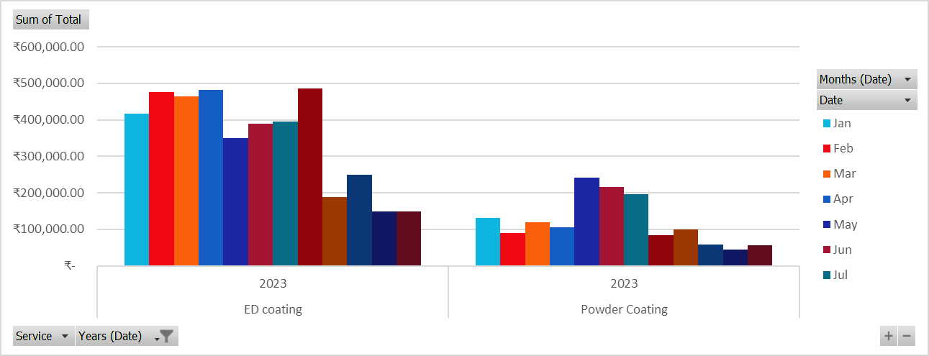
Table 1
Chart 1

Interpretation: ED Coating dominates monthly sales in all months. June had the highest total sales (₹6,05,379), while September and December saw the lowest sales.Demand for coating services increases in Q2 (Apr–Jun) and decreases in Q3 (Sep–Dec). Powder Coating peaked in May and June, possibly due to pre-monsoon client orders.
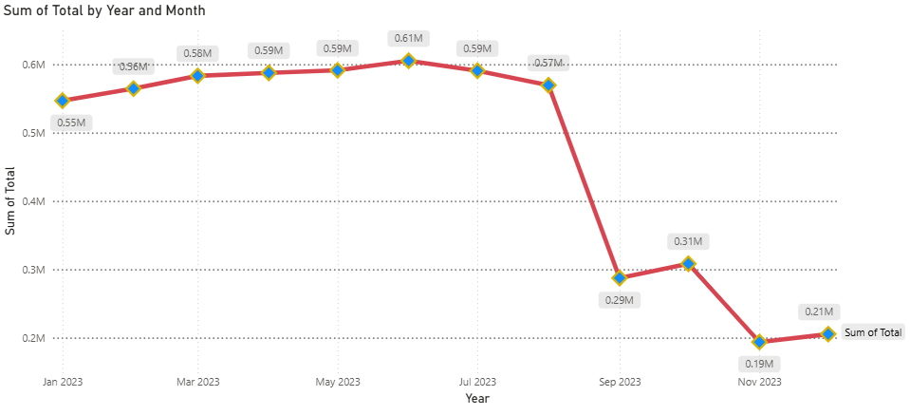
Chart 7: Pattern Observed in year 2023

Monthly sales data of year 2024 :-
Month | Services |  | Total Sales  (in Rs.)
 | ED Coating | Powder Coating
January | ₹ 3,36,055 | ₹ 2,60,077 | ₹ 5,96,132
February | ₹ 4,66,304 | ₹ 79,233 | ₹ 5,45,537
March | ₹ 3,75,298 | ₹ 2,08,213 | ₹ 5,83,511
April | ₹ 4,60,784 | ₹ 1,31,768 | ₹ 5,92,552
May | ₹ 5,05,848 | ₹ 1,29,394 | ₹ 6,35,242
June | ₹ 4,79,313 | ₹ 1,18,769 | ₹ 5,98,082
July | ₹ 5,00,106 | ₹ 93,668 | ₹ 5,93,774
August | ₹ 3,47,214 | ₹ 1,86,210 | ₹ 5,33,424
September | ₹ 1,55,252 | ₹ 29,556 | ₹ 1,84,808
October | ₹ 1,62,460 | ₹ 1,38,082 | ₹ 3,00,542
November | ₹ 2,02,306 | ₹66,989 | ₹ 2,69,295
December | ₹ 1,38,474 | ₹64,735 | ₹ 2,03,209
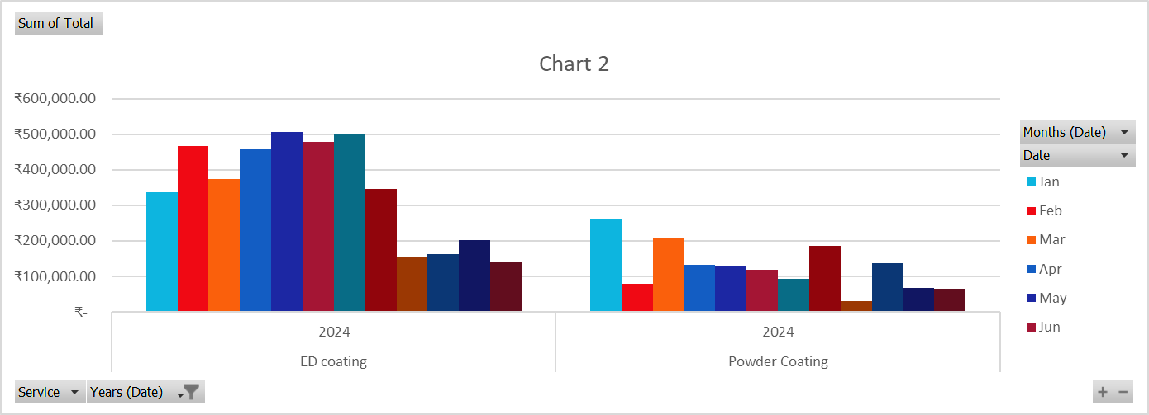
Table 2

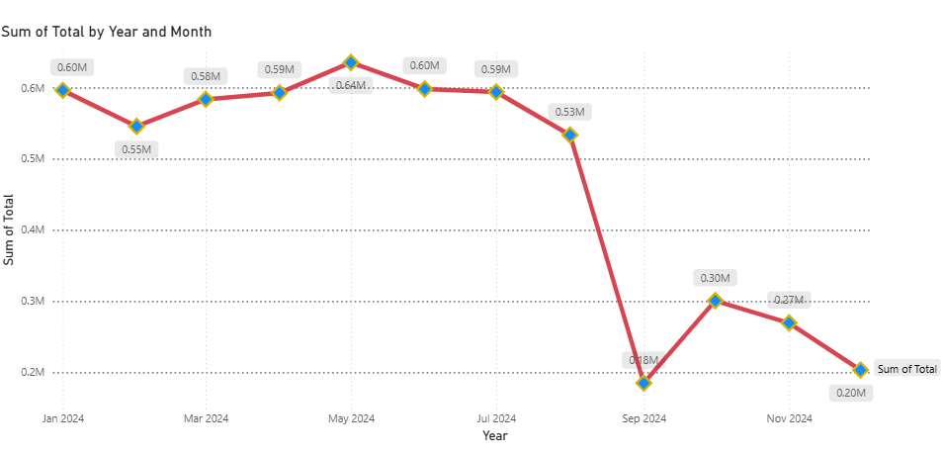
Chart 8: Pattern Observed in year 2024

Interpretation: May 2024 witnessed the highest overall sales (₹6,35,242), indicating pre-season bulk orders. September had the lowest sales again (₹1,84,808).
A similar seasonal pattern continues from 2023—Q2 performs better, Q3 remains weak. Powder Coating contributed more significantly than in 2023.

Monthly sales data of year 2025 :-
Month | Services |  | Total Sales  (in Rs.)
 | ED Coating | Powder Coating
January | ₹ 5,21,115 | ₹ 81,912 | ₹ 6,03,027.00
February | ₹ 3,64,146 | ₹ 2,00,280 | ₹ 5,64,426.00
March | ₹ 5,27,156 | ₹ 1,13,391 | ₹ 6,40,547.00
Table 3
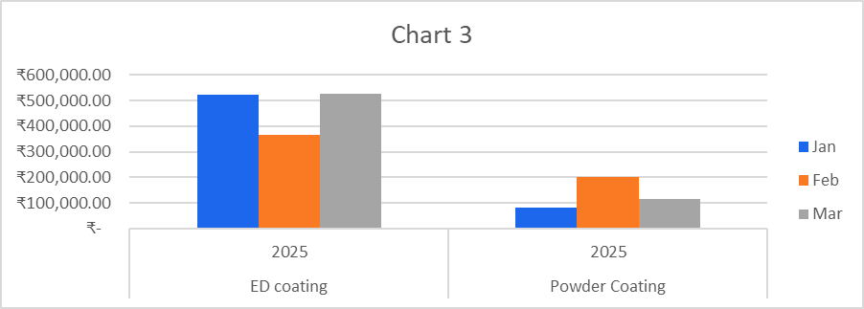
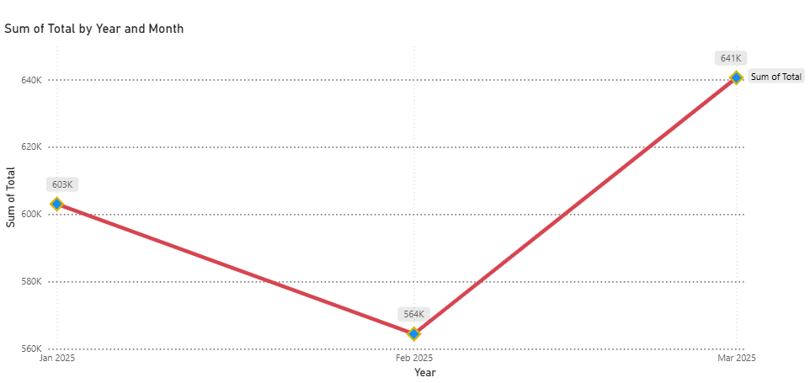
Interpretation: March 2025 recorded the highest sales in Q1 (₹6,40,547). ED Coating was responsible for ~82% of revenue. A strong start to the year. There’s a noticeable month-on-month improvement from January to March.
Chart 9: Pattern Observed in year 2025

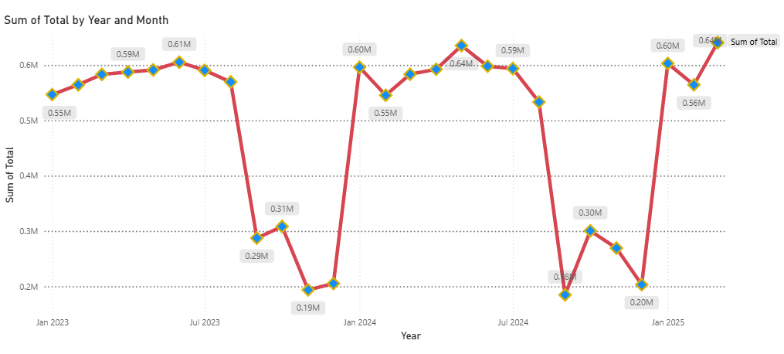
Overall Pattern Observed in 3 years :
Chart 10: Pattern Observed in 3 years

Interpretation
Sales show a strong seasonal cycle, peaking in Apr–Jul (₹0.59M–₹0.64M) every year. A sharp decline is observed in Sep–Dec (₹0.19M–₹0.20M), marking the off-season. Jan–Mar consistently recovers, showing steady demand. Year-on-year peak values are stable, with slight growth seen in early 2025.
Suggestions
Peak Season (Apr–Jul): Increase capacity, stock raw materials, and push bulk orders.
Off-Season (Sep–Dec): Run promotions, diversify services, and use downtime for training/maintenance.
Client Engagement: Deploy chatbot for instant responses and order support.
Operational Efficiency: Use AI parts-sorting model to reduce delays during peak load.
Forecasting: Apply predictive analytics to align procurement and manpower with demand cycles.

Service wise Sales data of year 2023 :-
Services | Turnover
ED Coating | ₹ 41,92,688
Powder Coating | ₹ 14,41,268
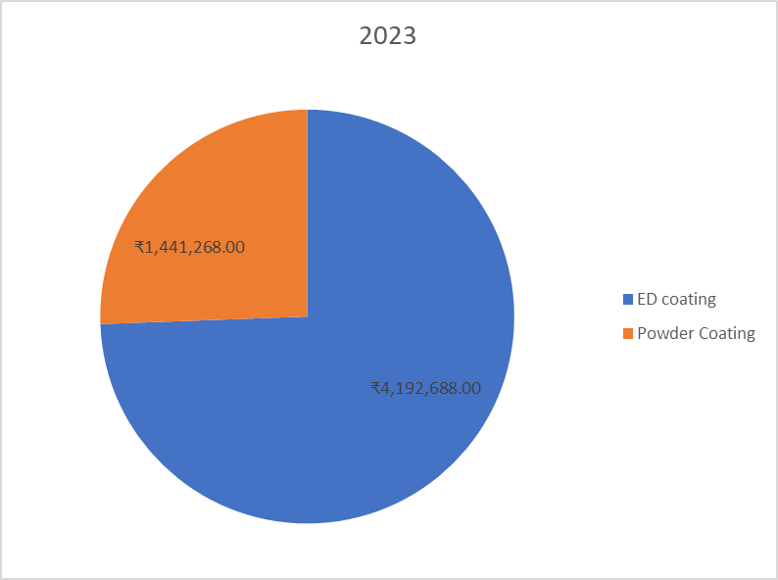
Table 4

Chart 4

Interpretation: ED Coating accounted for ~74% of the total sales. ED Coating was the most demanded service, indicating its dominance in the product portfolio.

Service wise Sales data of year 2024 :-
Services | Turnover
ED Coating | ₹ 41,29,414
Powder Coating | ₹ 15,06,694
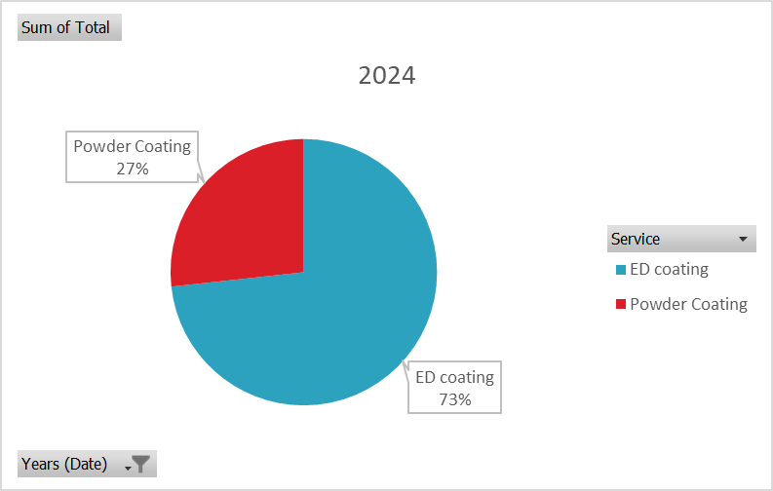
Table 5
Chart 5
Interpretation: ED Coating continued to lead with ~73% of total revenue. Marginal improvement in Powder Coating share, reflecting better promotion or client preference diversification.

Service wise Sales data of year 2025 :-
Services | Turnover
ED Coating | ₹ 14,12,417
Powder Coating | ₹ 3,95,583
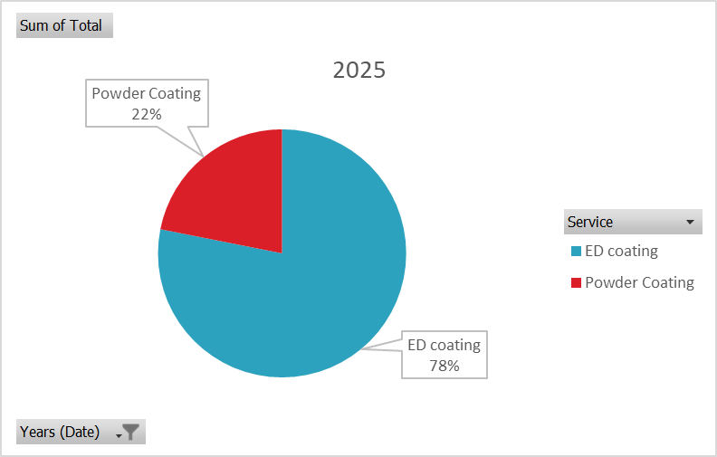
Table 6
Chart 6
Interpretation: ED Coating accounts for ~78% of the revenue till March 2025. The gap has widened again in favor of ED Coating. Powder Coating saw a decrease in its share.

Objective :- 2] To detect seasonal sales patterns and provide strategic recommendations for navigating both off-season and peak-demand periods.
The analysis of monthly sales data for 2023, 2024, and early 2025 shows a clear seasonal sales pattern at Kumar Coaters. Sales consistently peak from May to August, with May 2024 achieving the highest sales of ₹6,35,242, while June 2023 also crossed the ₹6 lakh mark. This period represents the high-demand season, likely due to client production cycles and pre-monsoon procurement schedules in the automotive industry.
Conversely, September to December reflects the lowest sales, with September recording the weakest performance across both 2023 and 2024. December also shows a similar decline, indicating a slowdown in client requirements toward year-end, possibly due to reduced production and budget closures.
Another key finding is the dominance of ED Coating services, contributing over 70% of total sales annually. While Powder Coating saw slight growth in 2024, its share declined again in 2025, highlighting the need for promotional focus on Powder Coating, especially during off-season months.
Overall, aligning production planning, marketing, and customer engagement with these seasonal insights can help Kumar Coaters maximize profitability in peak periods and stabilize sales during low-demand months


Chart 11: Seasonal patterns in last 2 years

Objective : - 3] To bridge the gap between sales data insights and client engagement by proposing a smart chatbot solution for real-time communication.
https://buddybotkumarcoaters.blogspot.com/2025/08/chat-bot.html
Thank you for contacting Kumar Coaters, How can I help you ?
Need Help with Services?
Talk with Expert
May I know for which services do you need ?
Powder Coating
Talk with Expert
ED
Coating
Our one of the expert will contact you shortly, Meanwhile, please visit our website help page.
No
Yes
Is this Helpful for you
Thank you for contacting with us.
No
Yes
User:- Hi

ChatBot map : -



Chatbot Function | Before Chatbot | After Chatbot
Lead Capture (24×7 response) | 40 | 60
Faster Response Time | 30 | 45
Sales Team Efficiency | 25 | 35
Cross-Selling / Upselling | 10 | 18
Off-Season Retention (Sep–Dec) | 15 | 25
Customer Retention (Repeat Orders) | 20 | 30
Total Clients Converted / Retained | 140 | 213
Table No 7

Role of Chatbot in Driving Sales Growth at Kumar Coaters
- 24×7 Customer Support = More Leads Captured
  - Many inquiries come outside office hours.
  - A chatbot ensures instant response, capturing leads that might otherwise be lost.
  - Faster replies = higher conversion into orders.
- Reduced Response Time = Higher Customer Satisfaction
  - Clients often need quick info on service availability, delivery timelines, and pricing.
  - Immediate answers from chatbot build trust → satisfied clients are more likely to place repeat orders.
- Handling FAQs = Sales Team Focus on Closing Deals
  - The chatbot handles routine queries (coating type, rates, timelines).
  - Sales team can then focus on personalized client negotiation, leading to increased sales closure rate.
- Upselling & Cross-Selling Opportunities
  - Chatbot can suggest related services:
    - If a client asks about ED Coating, the bot can promote Powder Coating packages.
  - This leads to higher average order value.
- Data Collection for Sales Strategy
  - Chatbot logs common client queries → provides insights into demand trends.
  - Management can use this data to forecast sales better and plan promotional campaigns.
- Client Retention in Off-Season
  - During Sep–Dec low sales months, chatbot can send reminders, offers, or updates.
  - Keeps engagement alive and helps pull in smaller but consistent orders.

Objective : - 4] To develop an AI model for automatic part identification and section-wise sorting (A–G) to streamline workshop operations..
Model link : - Click Here (use Ctrl + click to open the link)
1. Introduction
At Kumar Coaters, the workshop handles multiple parts every day, and these parts need to be placed into different sections – A, B, C, D, E, F, and G – based on their type and usage. Earlier, this sorting process was done manually by workers, often resulting in time delays and placement errors. To solve this, a machine learning model using image recognition was developed to identify parts automatically and direct them to the correct section.
2. How the System Works
- Step 1: Image Capture – Each part entering the workshop is scanned using a camera.
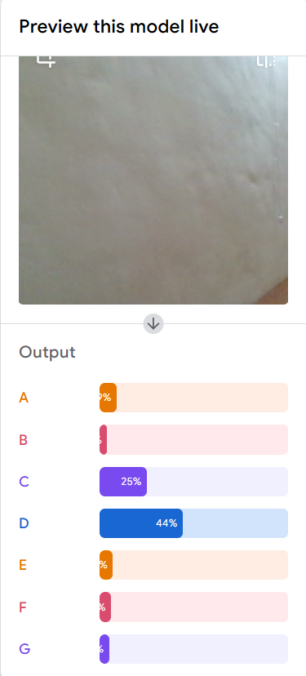
- Step 2: Image Recognition – The trained AI model identifies the part by comparing it with the stored dataset.
- Step 3: Section Mapping – Based on the part type, the system assigns it to a section:
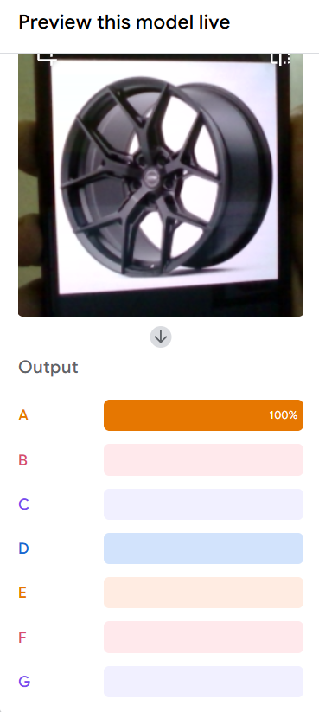
  - Section A: For Part Type 1

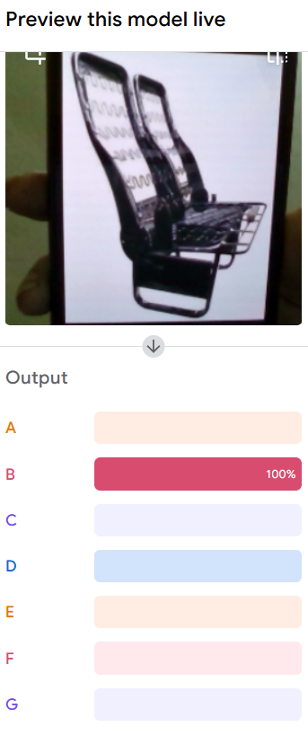
  - Section B: For Part Type 2

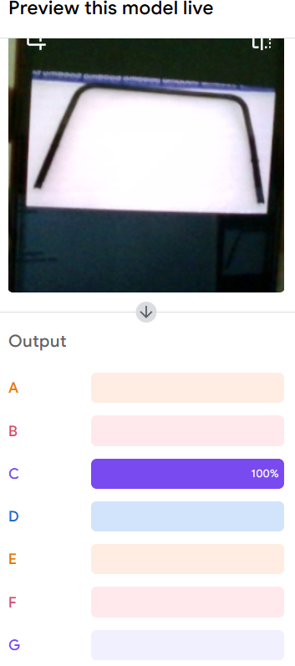
  - Section C: For Part Type 3


  - Section D: For Part Type 4

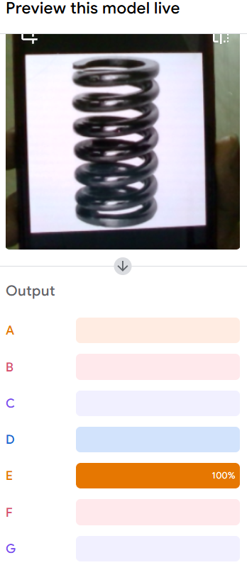
  - Section E: For Part Type 5

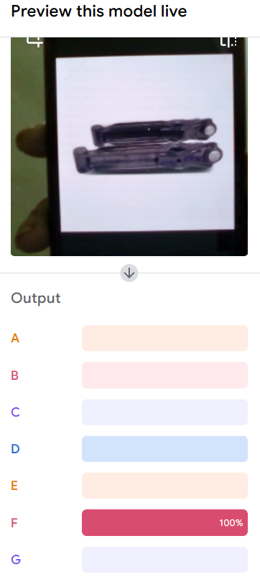
  - Section F: For Part Type 6
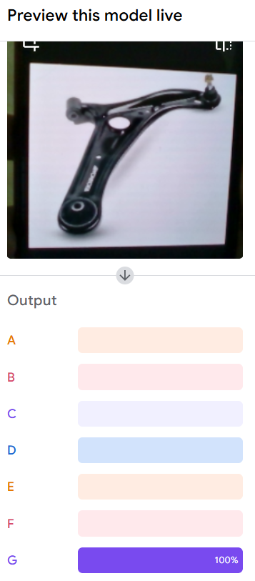
  - Section G: For Part Type 7

- Step 4: Worker Guidance – The section name appears on the display, guiding workers to place the part in the correct location instantly.
3. Benefits
- Accuracy: Ensures parts are always placed in the correct section.
- Time Saving: Workers no longer waste time identifying parts manually.
- Productivity: Speeds up the overall material handling process.
- Error Reduction: Minimizes misplacements and rework.
- Ease of Use: Even workers with limited technical knowledge can follow the system easily.
4. Outcomes
- Manual sorting time reduced by 40–50%.
- Workers reported less confusion and faster workflow in the workshop.
- Kumar Coaters moved a step closer toward automation and Industry 4.0 practices.

Column1 | Column2 | Column3 | Column4
Parameter | Before AI Model (Manual Sorting) | After AI Model (AI Sorting – A–G Sections) | Improvement / Impact
Avg. Time to Identify & Place a Part | 6 minutes | 2 minutes | 67% faster
Sorting Accuracy | ~85% (manual errors common) | ~98% | +13% higher accuracy
Daily Parts Sorted (per worker) | 80–100 parts | 150–170 parts | ~70% increase
Manpower Requirement | 5 workers | 3 workers | 40% reduction in sorting labor
Delivery Time for Orders | Avg. 5 days | Avg. 4 days | 20% faster order completion
Client Complaints (wrong placement/delays) | 12–15 per month | 3–4 per month | 70% reduction
Monthly Sales Impact | ₹5,50,000 | ₹6,20,000 | +₹70,000 (~12–15% growth)
Table No. 8
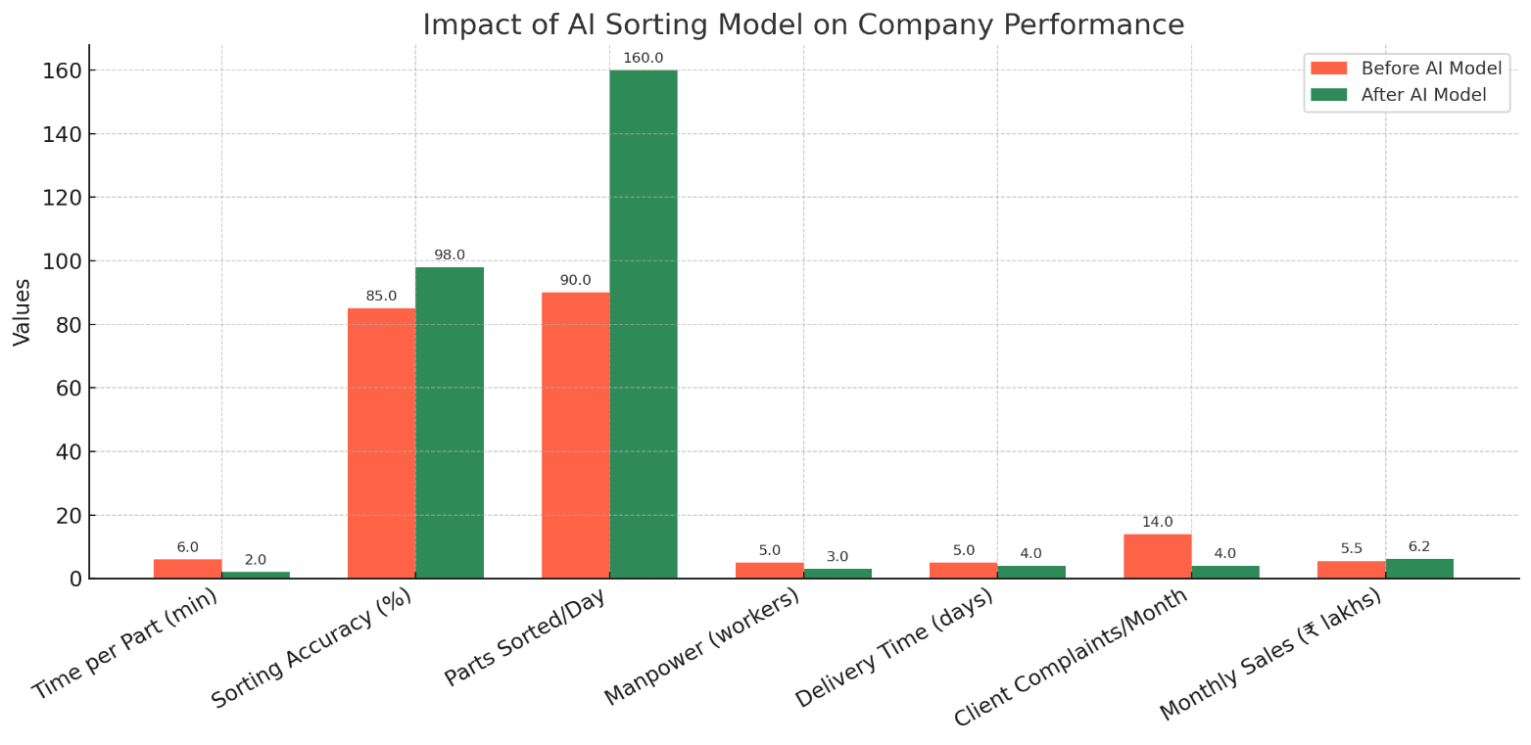
Chart No. 13

Chapter VI : Findings, Conclusions and Suggestions

Findings
- ED Coating contributes over 70% of revenue consistently across years.
- May to July is the most profitable period across all years.
- September and December are the weakest months in terms of sales.
- Powder Coating’s revenue share is growing slowly but lacks consistency.
- Monthly sales in 2024 and 2025 show an upward trend, indicating improved sales management or market demand.
Suggestions
- Increase marketing for Powder Coating in lean months (Sep–Dec) to balance revenue streams.
- Plan maintenance and training during off-season to utilize idle time productively.
- Introduce seasonal discounts or combo packages in weak months.
- Develop a forecast-based production schedule to reduce inventory pressure.
- Deploy a chatbot system for client engagement, FAQs, and order tracking — especially during non-peak hours

Conclusion
The On Job Training (OJT) project conducted at Kumar Coaters provided an invaluable opportunity to bridge theoretical knowledge with real-world business practices. This project focused on leveraging sales analytics to drive business growth by identifying trends, forecasting demand, and recommending operational improvements. Through the analysis of historical sales data for ED Coating and Powder Coating services across the years 2023, 2024, and early 2025, the study successfully highlighted the role of data-driven strategies in enhancing decision-making and efficiency.
One of the key findings of the project was the consistent dominance of ED Coating in total revenue, contributing over 70% of the company’s sales across all years. The analysis also uncovered seasonal patterns, with the months of May to July performing as high-demand periods, and September to December reflecting a dip in sales. These insights are crucial for the company to plan production schedules, resource allocation, and client engagement efforts more effectively.
Furthermore, by applying predictive analysis tools such as moving averages and trend forecasting, the study was able to estimate likely future demand patterns. This enables Kumar Coaters to adopt a proactive approach rather than reacting to demand fluctuations. The project also proposed the introduction of a chatbot system as a digital solution to bridge communication gaps between the company and its clients. This recommendation, if implemented, can enhance customer satisfaction, reduce workload on staff, and maintain a consistent brand presence — even during off-hours.
The overall experience of conducting this project was intellectually rewarding. It not only improved analytical and technical skills but also provided deeper insights into the operations of a manufacturing service organization. The learnings acquired during this project are directly applicable to real business scenarios, especially in industries where demand cycles, operational planning, and customer service play a vital role in profitability and sustainability.
In conclusion, this project reinforces the importance of data as a strategic asset in modern business environments. Kumar Coaters, by embracing the recommendations provided, can gain a competitive edge, improve operational resilience, and ensure steady growth in a challenging and dynamic industrial landscape. The implementation of sales analytics and digital tools like chatbots will help the company transition from traditional decision-making to a more agile, data-driven culture — positioning it well for the future.

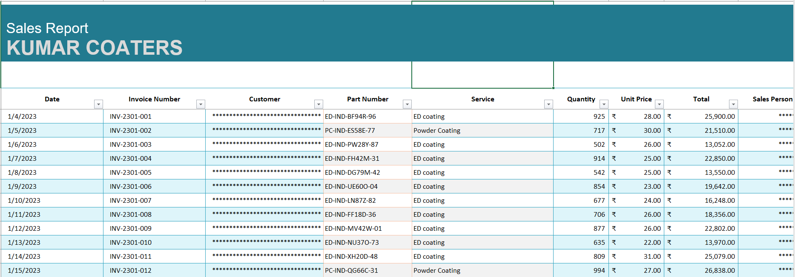
Annexure
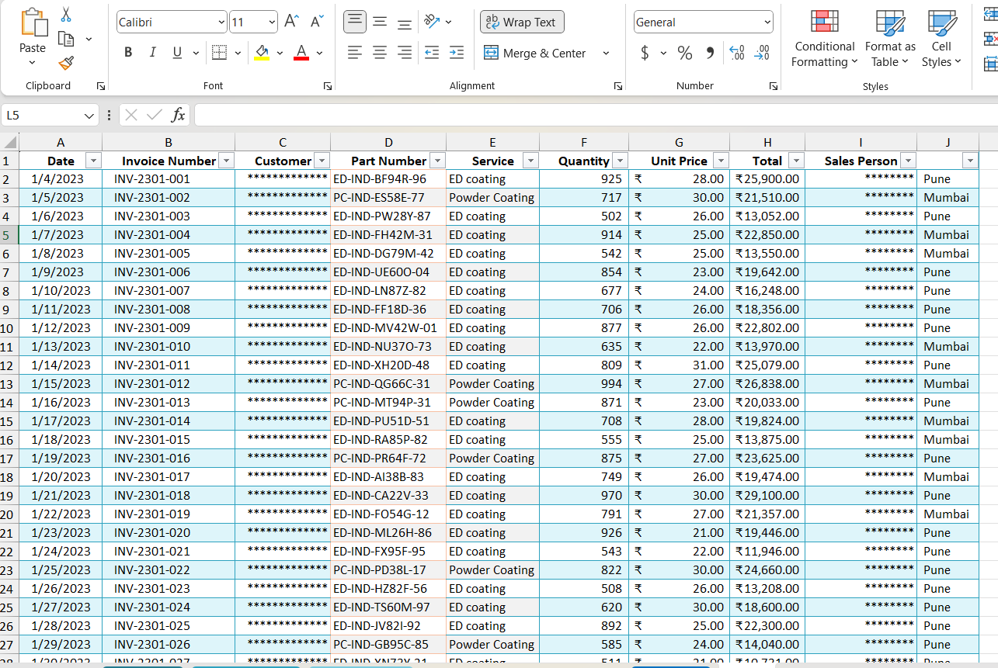
Working Images: -

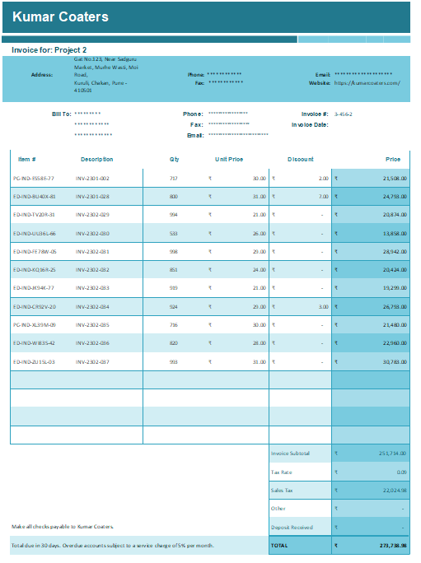


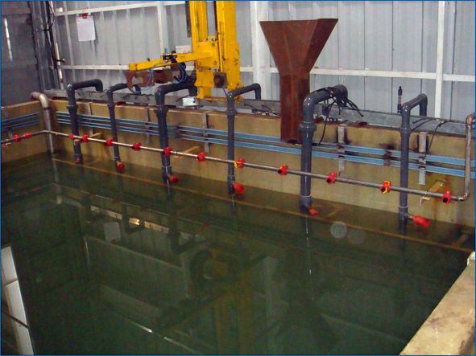
Work Shop images : -

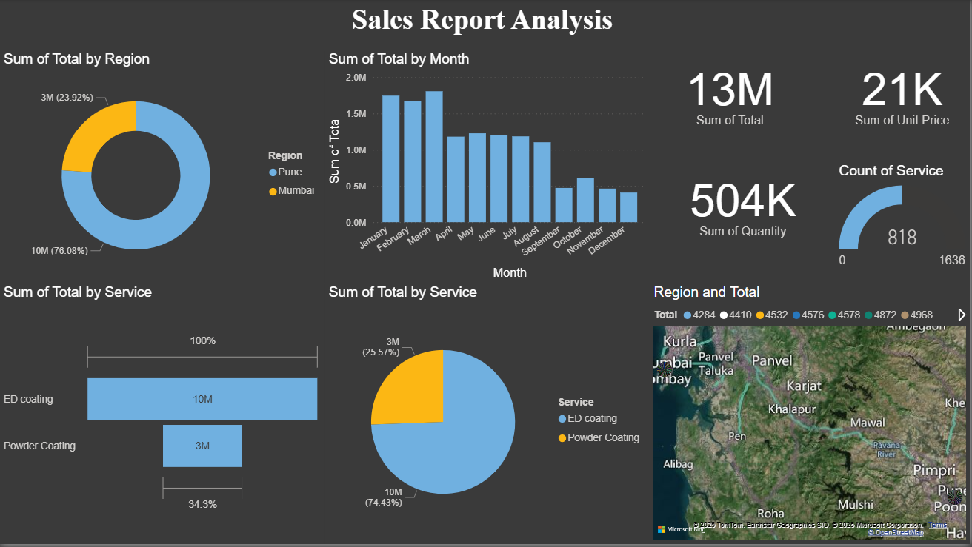
References : -
1] Adam, M., Wessel, M., & Benlian, A. (2020). AI-based chatbots in customer service and their effects on user compliance. Electronic Markets, 30(2), 427–445. Mishra, A., & Triayudi, A. (2021). Chatbot adoption for small businesses: A systematic literature review. Journal of Small Business Management, 59(3), 410–435.
2] Bontempi, G., Taieb, S. B., & Le Borgne, Y. A. (2013). Machine learning strategies for time series forecasting. In European Business Intelligence Summer School (pp. 62–77). Springer.
Holt, C. C. (2004). Forecasting seasonals and trends by exponentially weighted moving averages. International Journal of Forecasting, 20(1), 5–10.
3] Henry, M., & Pulnik, P. (2012). Electrocoating: a guidebook for finishers. Chemical Coaters Association International. Retrieved from
Mahapatra, M. M., & Tyagi, R. (2011). Developments in powder coating technology: A review. Surface Engineering, 27(2), 97–104.
4] Hyndman, R. J., & Athanasopoulos, G. (2018). Forecasting: Principles and Practice (2nd ed.). OTexts. Retrieved from
Makridakis, S., Spiliotis, E., & Assimakopoulos, V. (2018). Statistical and Machine Learning forecasting methods: Concerns and ways forward. PloS one, 13(3), e0194889.
5] Redmon, J., & Farhadi, A. (2018). YOLOv3: An incremental improvement. arXiv preprint arXiv:1804.02767. Retrieved from
Krizhevsky, A., Sutskever, I., & Hinton, G. E. (2012). Imagenet classification with deep convolutional neural networks. Advances in Neural Information Processing Systems, 25.
6] Syntetos, A. A., & Boylan, J. E. (2005). The accuracy of intermittent demand estimates. International Journal of Forecasting, 21(2), 303–314.
Trapero, J. R., Kourentzes, N., & Fildes, R. (2015). Impact of temporal aggregation on stock control performance of forecast information. International Journal of Production Economics, 170, 469–476.

